Docker Lab2

1. Problem 1:

Create bridge network with subnet 192.168.0.0/24.

Run 2 containers and attach containers to this network.

Create another bridge network with subnet 10.5.0.0/24.

Run any container and attach it to the new network.

Make sure that the containers at different network can’t ping each other

1. Create a bridge network with subnet 192.168.0.0/24:



1. Run 2 containers and attach them to this network:

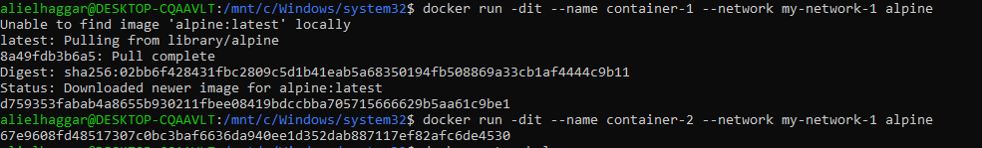

1. Create another bridge network with subnet 10.5.0.0/24:



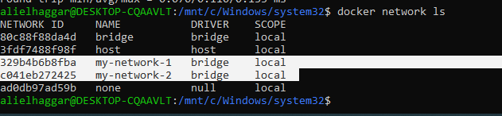

1. Run any container and attach it to the new network:



1. Make sure that the containers at different networks can’t ping each other:

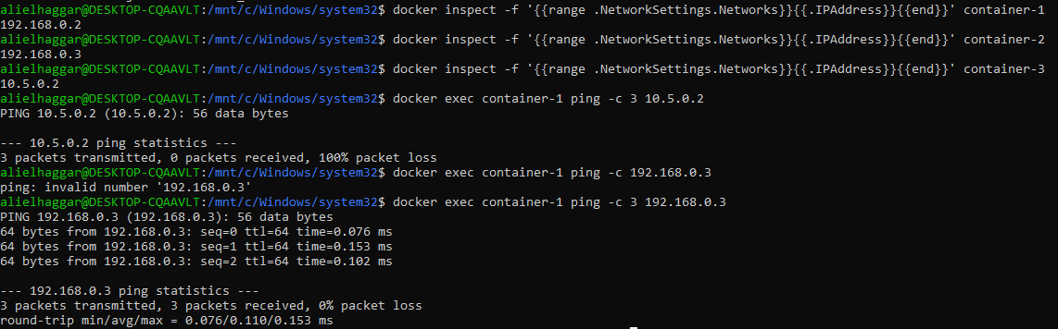

2. Problem 2:

Create static html file

Write Dockerfile to build image based on httpd to host the html file and

specify the following

Copy the html file.

Copy a new configuration file to listen on port 9999 instead of 80

Open the port 9999 in the container

Add environment variable CONTAINER with value docker .

Add startup command to echo the variable

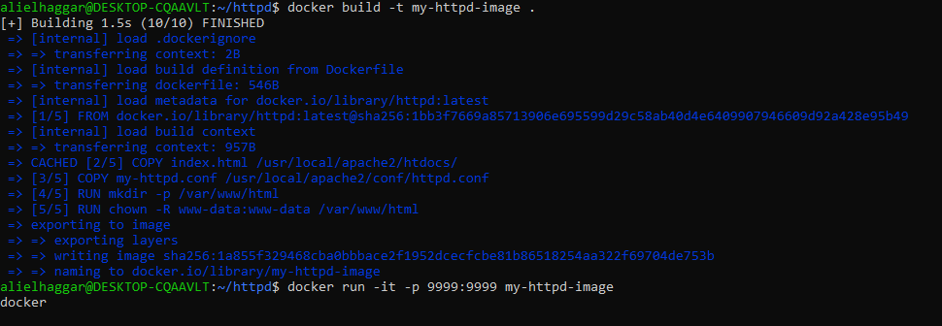

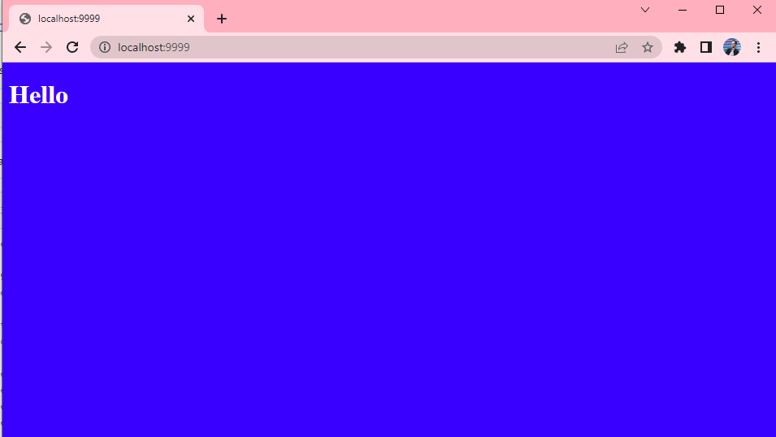

3. Problem 3:

Create a docker compose to up mysql container, and

https://github.com/sabreensalama/dockerize-node-app-task which depend on mysqldb.

Add volume for mysqldb

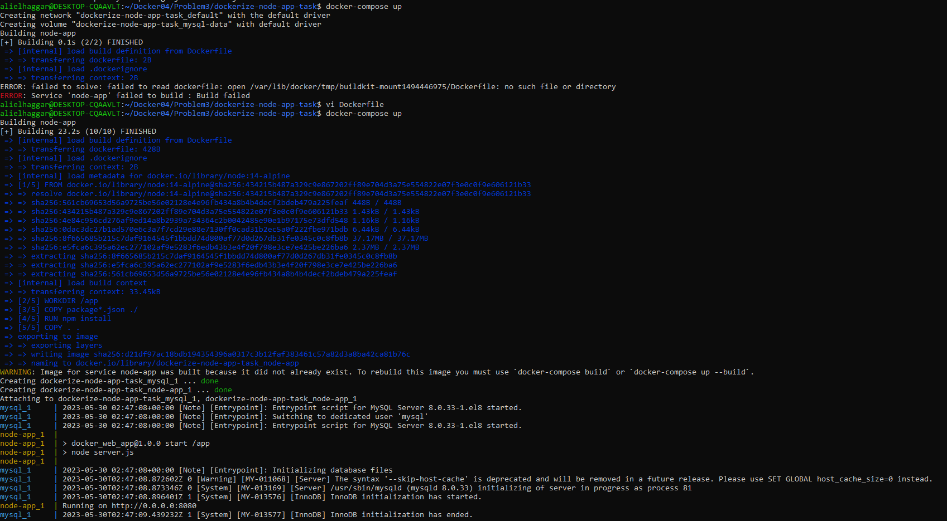

4. Problem5:

Use docker compose to deploy ghost platform (image: ghost:1-alpine)(Ghost is a free and open source blogging platform written in JavaScript)

Use mysql database instead of sqlite

